Invitation to the 3rd Belgian Sambo Open
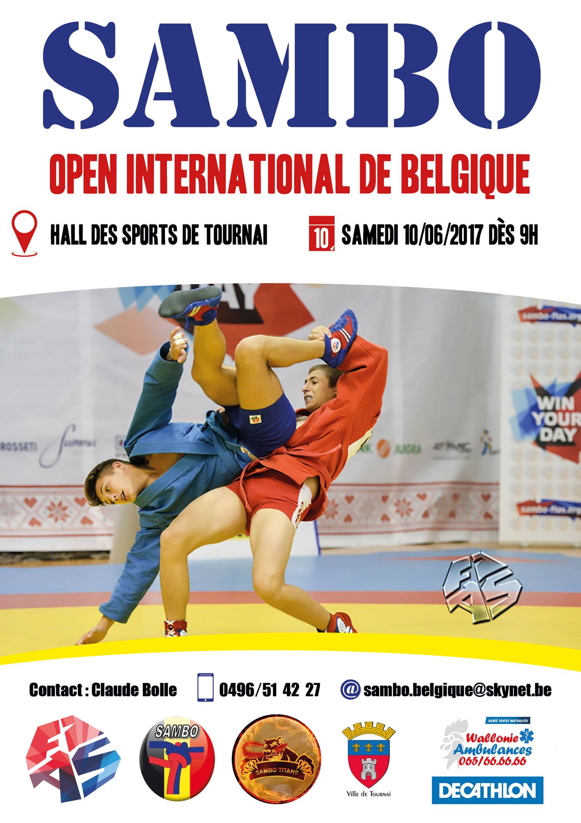

- General information
The BASFAD has the pleasure to invite you to the 3rd Belgian Sambo and combat Sambo Open.
The competition is organised according the FIAS rules.
The goal of this tournament is to develop Sambo in Belgium and Europe. We also aim at developing friendship with other federations and nations.

- Where and when?
Gym : Hall des Sports de la Ville de Tournai, Avenue De Gaulle 2, 7500 Tournai (90 km from Brussels), Belgium.
Date: 10th June 2017.

- Athletes participation
Athletes willing to take part in the competition should be registered by their national federation and by the FIAS.
Athletes should also bring their own equipment as described in official rules.
The completed participation forms should be sent to: sambo.belgique@skynet.be before 15th May 2017.
The participation fee is 15€/athlete (Non-EU delegations should contact the BASFAD before paying the fee). The fee should be paid on the bank account IBAN BE92 6528 4669 7423.

- Weight and age categories :

Sambo :

’2000-older Men -62, -68, -74, -82, -90, +90 kg
Women -56, -60, -64, -68, -72, +72 kg
Veterans Men -74, -82, -90, +90 kg (from 35 years of age)

Sambo Combat :

’99-older Men -62, -68, -74, -82, -90, +90 kg

- Support from the BASFAD
The BASFAD will give required invitation documents in order to get a visa.
We will also help foreign delegations to find affordable accommodation.

- Timing

Friday 9th June
6.30 pm | Weighting
Saturday 10th June
7.30 to 8.30 am | Weighting
8 am | Judges meeting
8.45 am | Coaches meeting
9 am | Beginning of the matches ( both sport and combat sambo)
6/7 pm | Finals

NB :
The B.A.S.F.A.D. reserves the right to fuse weight categories if the number of fighters is not sufficient. Following many demands from federations, the sport sambo competition is open to the juniors and youth age divisions.

- Place

Sports hall of the town of Tournai

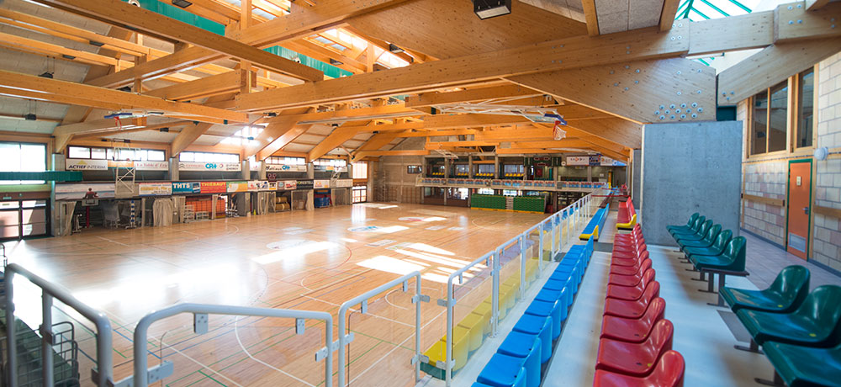

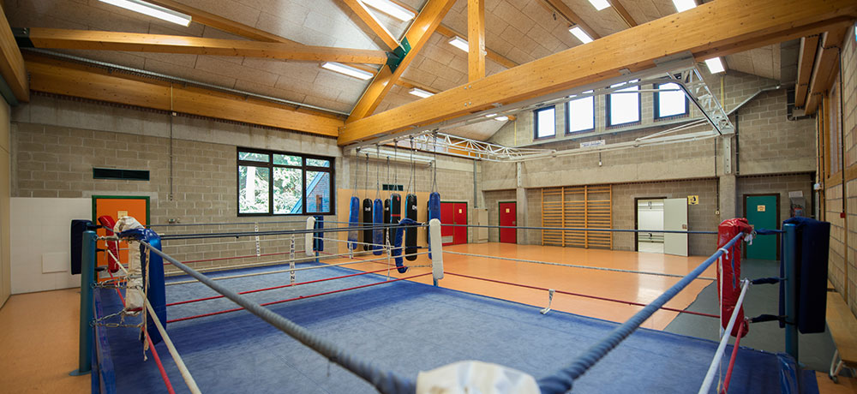

- Accomodations
There are several different hotels (cheap, middle and high-end) located near the sports complex.
Here are some of them :
- Hostel of Tournai (cheap)

- Internet link : click here
- Short description : located in the heart of Tournai, i twill take you only 10 minutes to get from the hostel to the sports hall
- Night (without food) from 19 € a night

- Studio/Apartment Tournai (middle)

- Internet link : click here
- Short description : scattered in Tournai, those flats are ideal to enjoy and comfortable and short stay
- Night (without food) from 60 € a night

- Le Haras des Chartreux (high-end)

- Internet link :click here
- Short description : fantastic hotel located to 20 km away from the sports hall
- Night (without food) from 80 € a night

Transportation will be organised between :
- Airports/stations and hotels ;
- Hotels and sports hall.

Subscription Form
Country: | Total Amount of members:
Arrival date and time:  Airport:  Flight No: | Supposed means of transport:  [Air Company name or other ]
Departure date and time:  Airport:  Flight No: | Transfer: to / from airport  to / from railway station

№ | Name | Function | Date of birth | Weight category | Pass №
1
2
3
4
5
6
7
8
9
10

We undersigned, attest that the athletes selected in the list by our Federation are assured for the actual sport season

Signature and Stamp of Federation

Visa Application Form

№ | Name | Date of birth | Pass № | nationality | Date of issue | Date of expiry

Signature :

