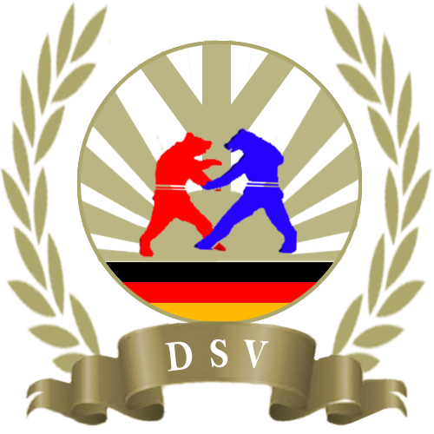

∗∗∗ SAMBO GERMANIADE 2014 ∗∗∗
International German Championships in
Sport und Combat Sambo

Organiser Deutscher Sambo Verband e.V.
Sambo Verband Berlin – Brandenburg e.V.
www.sportzentrum-hakenfelde.de
Harald Roller
AC Berlin e.V.
www.ac-berlin.de
Thomas Jüttner
Goals Distribution and integration of sambo art in Germany; integration of
sportsmen from ex CIS states in german society, development of international
relations between sportsmen
Date 07.11 – 09.11.2014
Place Sportforum Berlin, Weißenseer Weg 53, 13053 Berlin
Participants Only members of DSV, ESF and FIAS are allowed to start
! Every sportsman must have a health insurance
! Members of the DSV only with valid sambo passport (DSV) and JSM
Duration Youth: 3 – 4 Minuten
Women: 4 Minuten
Men: 4 – 5 Minuten
Tournament rules according to FIAS
Chief referee will be arranged by DSV
Chief secretary will be arranged by DSV
Referees will be arranged and devided up by DSV
Every team has to register a referee
Registrations must be made in electronic format stating the family name, first
name, birth date, weight class, club and contact person
to
Mr. Andrej Bart (german, russian, english)
Antwerpener Str. 14
13353 Berlin
Tel: (0049) 162/ 901 85 25
E-Mail: samboka@gmx.de
Information: Deutsche Sambo Verband e.V. is always ready to environmentally
conscious action. That means, that we try to work paperless. Also You
can help us. How? It’s simple: You send us your registrations by e-mail.
This will save your time and protect our environment. Registration form
can be found here.
Registration
deadline 15.10.2014
! Late registration is not possible
Entry fee 20 Euro each sportsmen and discipline to pay in cash before weighting
or
can be paid by bank transfer
account holder: DSV
bank: sparkasse westholstein
IBAN: DE92 2225 0020 0029 0003 60
BIC: NOLADE21WHO (Itzehoe)

Weight classes
2003, 2002 (11-12 years)

m: -30, -32, -35, -38, -41, -45, -49, -53, -57, -62, -67, +67
w: -26, -28, -30, -32, -34, -36, -38, -41, -45, -49, -53, +53

2001, 2000 (13-14 years)

m: -35, -38, -42, -46, -50, -54, -59, -65, -71, +71
w: -34, -37, -40, -43, -47, -51, -55, -59, -65, +65

1999, 1998 (15-16 years)

m: -42, -46, -45, -50, -55, -60, -66, -72, -78, -84, +84
w: 38, -41, -44, -48, -52, -56, -60, -65, -70, +70

1997 - 1996 (17-18 years)

m: -48, -52, -56, -60, -65, -70, -75, -81, -87, +87
w: -40, -44, -48, -52, -56, -60, -65, -70, -75, +75

1995 - 1994 (19-20 years)

m: -48, -52, -57, -62, -68, -74, -82, -90, -100, +100
w: -44, -48, -52, -56, -60, -64, -68, -72, -80, +80

Men and women

1993 and older

m: -52, -57, -62, -68, -74, -82, -90, -100, +100
w: -48, -52, -56, -60, -64, -68, -72, -80, +80

Combat Sambo (men)

1996 and older

-57, -62, -68, -74, -82, -90, -100, +100

Veterans

35-39 y., 40-44 y., 45-49 y., 50-54 y., 55-59 y.,60-64 y., 65 and older

-62, -68, -74, -82, -90, -100, +100

! If there is only one participant in the weight class, this will fight in agreement with the coaches and the chief referee in the next higher weight or age class

Battle mode According to rules of Internationalen Amateur Sambo Föderation (FIAS)

Number of mats 3 Sambo tarpaulins (depending on number of participants)

Awards Medals and certificate for 1-3 places, (if only one participant is in a weighting
class – no medal

Schedule

Friday, 07.11.2014

17:00 –22:00 p.m Registration and weighting for Sport Sambo

Saturday, 08.11.2014
10:30 a.m. Official opening

11:30 a.m. Start of battles

17:00 –19:00 a.m. Registration and weighting for Sport Sambo (veterans) and Combat Sambo

Sonday, 09.11.2014

10:30 a.m. Start of battles

Monday, 10.11.2014

Departure of the foreign teams

Accommodation Holiday Inn Hotel Berlin City East, Landsberger Allee 203, 13055 Berlin
or
Hotel Kolumbus GmbH, Genslerstraße 18, 13055 Berlin
Catering Food and drinks can be bought on the territory of the tournament.
Important Information

! Liability: All competitors assume no liability
! For accident and liability insurance itself has to take care
! Each sportsman must have health insurance
! Stalls are allowed only for the DSV certified dealer

Others

The outfit will be checked by the referees before fights, whether it conforms tot he rules of the FIAS

This tournament is considered by DSV as a qualification tournament for the European and World Championships for Youth and Junior, as well as the seniors in 2015
object to change

Annual brand
Attention: There are some changes in weight classes according to FIAS rules!
In kg according to rules of the FIAS

