INTERNATIONAL BEACH SAMBO
TOURNAMENT

21/07/2018 Larnaca, CYPRUS

DATE:
21/07/2018

PRE-EVENT:
13:00

MAIN EVENT START:
17:00

WEIGH-INS:
21/07/2018 13:30-14:30
International Beach Sambo Competitions MEN & WOMEN

WEIGHT CATEGORIES (Kg):
Men: -52, -62, -74, -90, +90
Women: -48, -56, -64, -72, +72

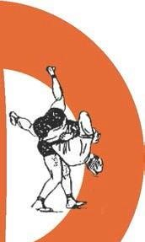
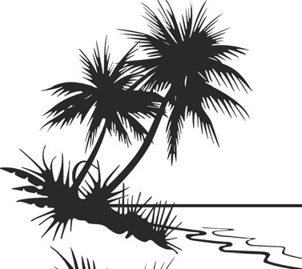
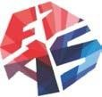
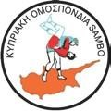
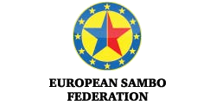
PLACE:
Finikoudes beach in Center of Larnaca City
CONTEST SYSTEM:
Official rules, FlAS beach Sambo
All athletes must have an official Sambo uniform without Sambo shoes Application fees: € 15.00
All participation applications must be sent to the following e-mail address: christinoscy@gmail.com using a specific form which will be sent to you

Accommodation in Larnaca cost is:
Double room Bed & Breakfast - 45€ per person per day
Triple room Bed & Breakfast - 40€ per person per day

ORGANIZER
Cyprus Sambo Federation
Phone: +357-99513619 / Fax: +357-22730617
E-mail: mariossambo@mail.ru
Best regards,
Organizing Committee
Marios Andreou
President of Cyprus Sambo Federation

